**Complete product backlog:**

1. Move instructions in ASSISTANT up where they belong
2. Debug in Gmail function and contact function
3. Directory email filtering
4. Password secure
5. Assistant app, including screen saver setting (type and wait time), module function setting and enhancing UI for add contacts
6. Update account setting debug
7. Account setting user interface enhancement
8. Check for new emails debug
9. User interface enhancement for video call
10. Ring bell while calling and receiving a call
11. Video call module
12. Voice phone call
13. Add back button in video call

**To do list**

1. Debug
   1. Screensaver start time (not stable on different PC)
2. 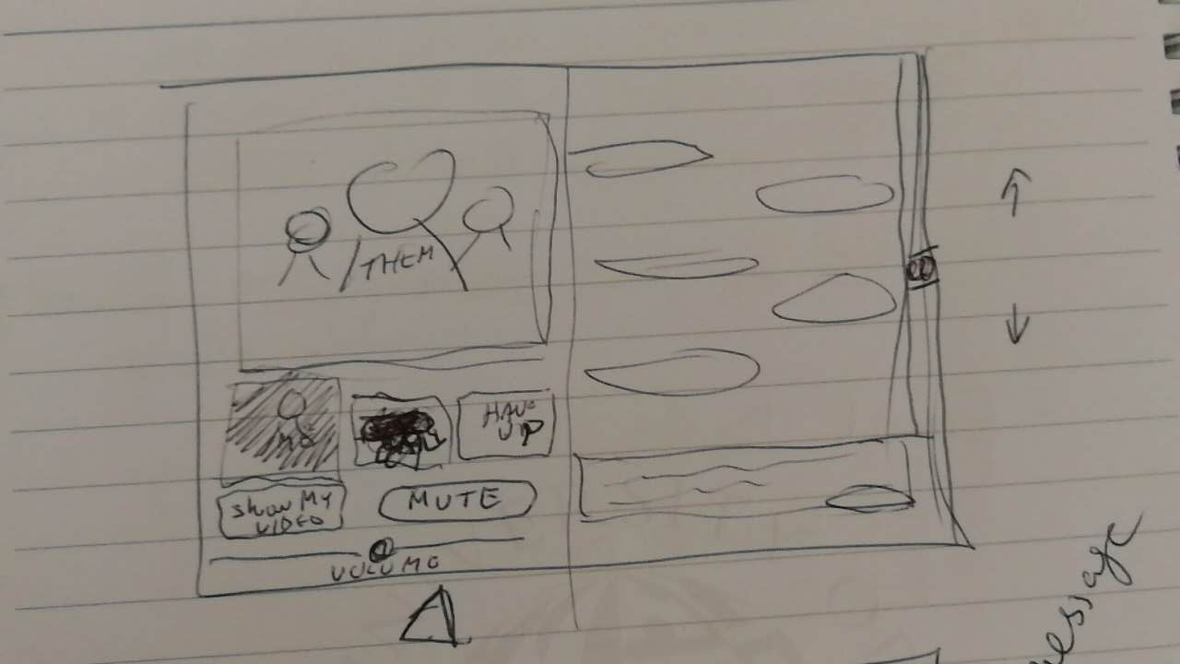New function
   1. Email
      1. Enable image viewing function
   2. Real-time communication
      1. Complete UI for message, audio and video windows
      2. Add message function or real-time text
   3. Photos
      1. Set “email” folder in google drive, automatically save email image attachment to the folder